**Requirements:**

Server with CentOS 7 with root privileges

- Disable SELinux

setenforce 0 sed -i 's/enforcing/disabled/g' /etc/selinux/config

- Install the requirements packages

yum install epel-release httpd php php-common php-mysqlnd php-mbstring php-gd mariadb-server mod_ssl zip wget unzip -y

- Configure and start both httpd and mariadb services

sed -i 's/AllowOverride none/AllowOverride all/g' /etc/httpd/conf/httpd.conf

systemctl start httpd && systemctl start mariadb

- Setup the database

mysql

CREATE DATABASE <name>;

GRANT ALL PRIVILEGES ON <name>.* TO '<name>'@'localhost' IDENTIFIED BY '<password>';

- Get and configure Joomla

wget https://github.com/joomla/joomla-cms/releases/download/3.6.4/Joomla_3.6.4-Stable-Full_Package.zip

unzip Joomla_3.6.4-Stable-Full_Package.zip -d /var/www/html/

chown -R apache:apache /var/www/html

- Open a browser and go to localhost

Set Parameters

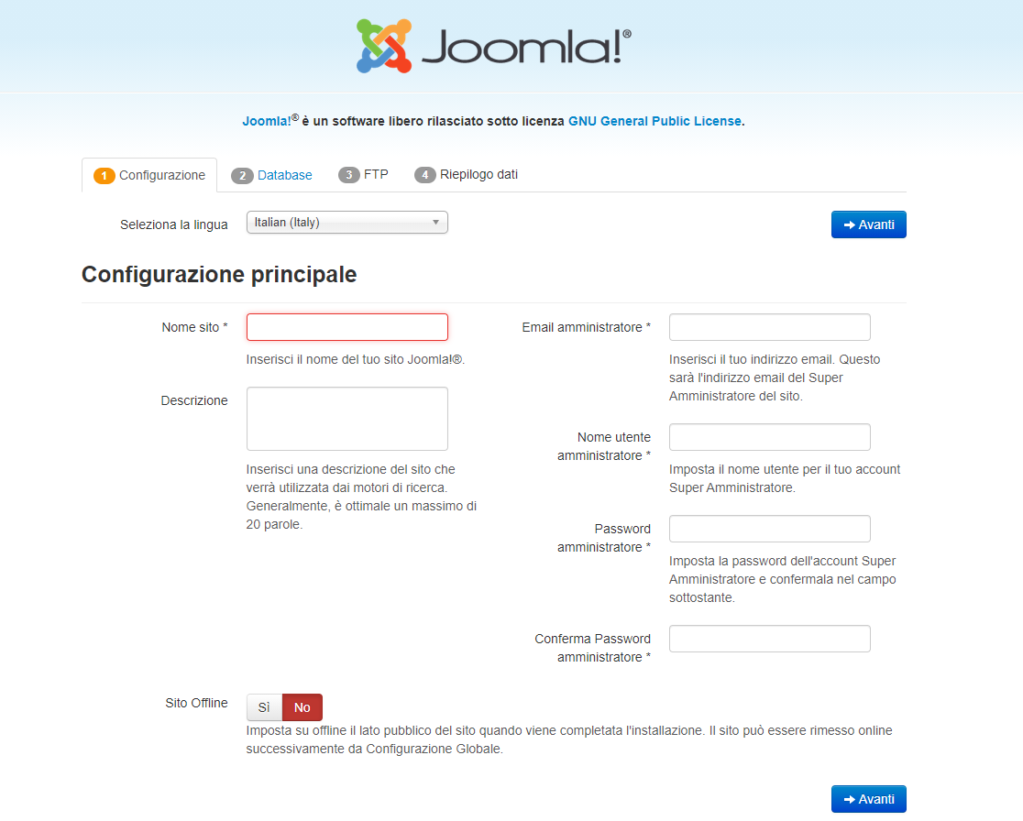

Set DB parameters configured previously

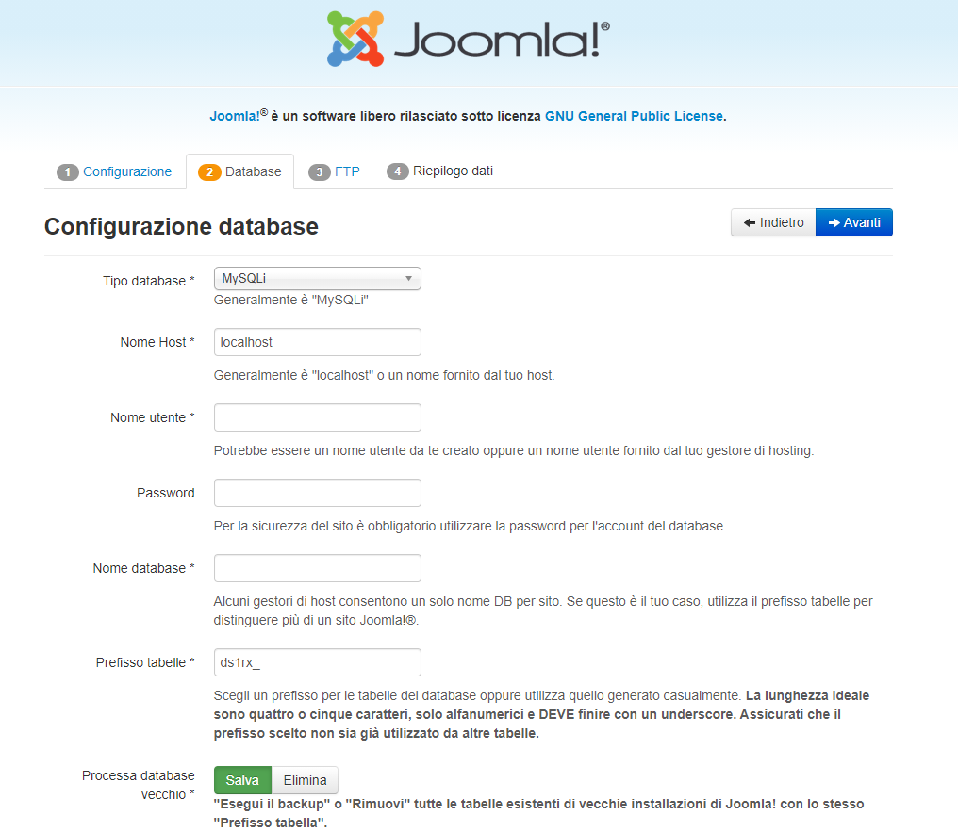

Set Parameters

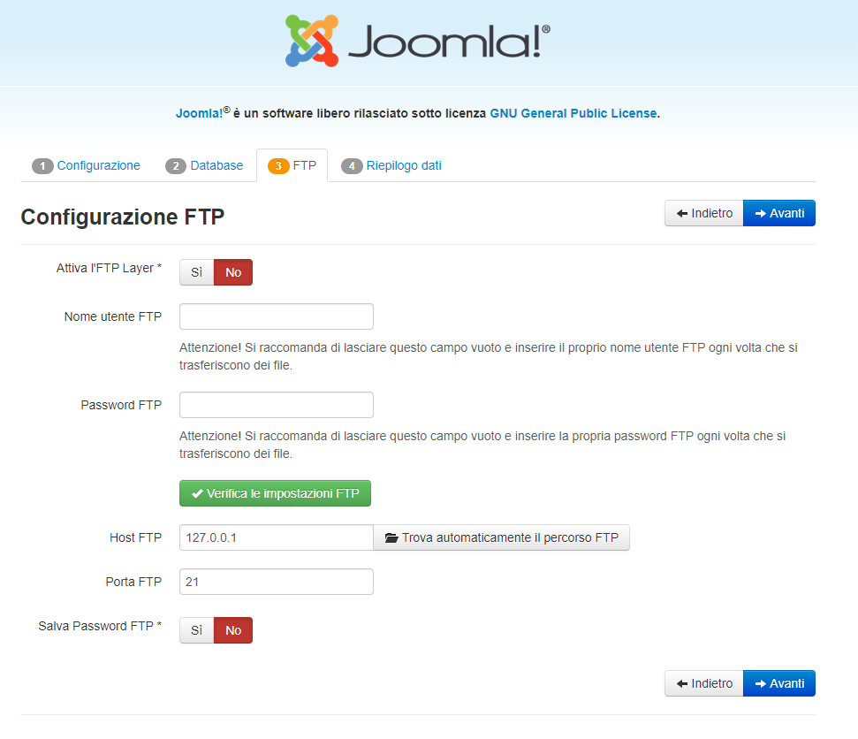

Select the following option

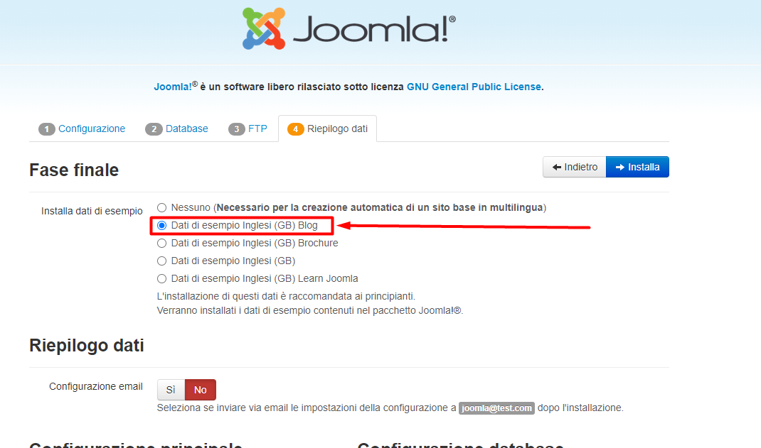

Select the following options

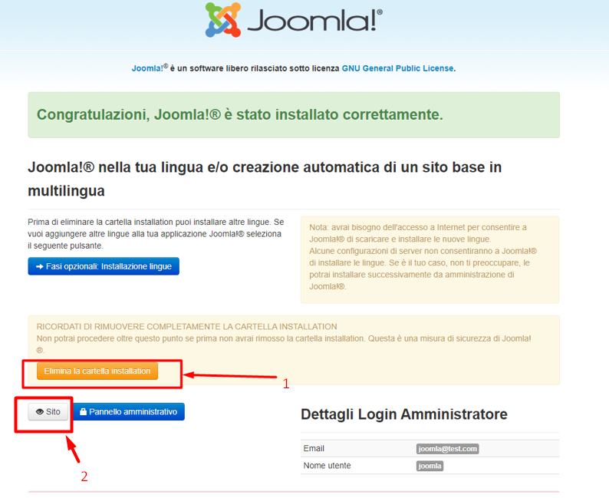

- Backup the webserver logs with rotation of 7 days

yum update && yum install logrotate -y

yum install vim -y

vim /etc/logrotate.d/httpd

- put the following parameters in the file

/var/log/httpd/*log {

daily

rotate 7

size 10M

compress

}

- Notification when more than 10 4xx requests are returned by application

yum install mailx -y

cd /etc/httpd/logs/

vim check_errors.sh

- put the following parameters in the file

#!/bin/bash

output=$(grep -i -o 'HTTP/1.1" 4[0-9][0-9]' * | wc -l)

if [ $output -gt 10 ]

then

echo "There are 10 or more 4** errors on your application" | mail -s "Joomla errors" receiver@example.com

fi

chmod 755 check_errors.sh

crontab -e

- put the following parameters in the file

0 */1 * * * root /etc/httpd/logs/check_errors.sh